Our Special Projects Success in 2012.
By Kym Henderson, PMI Sydney Chapter Special Projects Director.
A successful PMI Sydney Chapter Board strategic initiative for 2012 has been to “re-energise” interest in project controls and Earned Value Management in Australia. The initiative has demonstrated the benefits that can be obtained from the positive collaboration between professional bodies which has included:
- PMI Sydney and Canberra Chapters
- PMOZ Conference
- The USA based College of Performance Management
- The EVM Europe Association.

The tangible outcomes of this initiative so far have been:
  - A keynote presentation, at PMOZ and a ‘full house’ PMI Sydney Chapter event , across the combined project management and systems engineering conferences by Prof. Pierre Bonnal on “An Overview of and Lessons Learned from the CERN Large Hadron Collider project Ms. Lisa Wolf presenting and delivering a workshop (sponsored by Paxus) on “lessons Learned from Internal Project Surveillance”. Lisa is the Earned Value Management Focal point at Booz Allen Hamilton, a large USA based consulting firm which has a target market of large US Federal Government acquisition programs.
  - My presentation on a “Practical Focus on Earned Schedule”, a workshop on Applying the Earned Value Concepts to Commercial (IT) Projects and an Earned Value Schedule Masterclass.
  - Pierre and Lisa also participated in a “Grill the Experts” panel session at PMOZ, which was at times serious, but also on occasion quite humorous which canvassed a wide variety of topical project management subjects from audience questions.
As part of PMI Sydney Chapter outreach, the group also travelled to Canberra where Professor Bonnal presented to a large PMI Canberra Chapter audience on case study “Project Control 2.0 — How to Implement a Deliverable-Oriented Earned Value Management (EVM) Framework.” This case study was derived from CERN’s experience in managing large-scale accelerator projects, including the Large Hadron Collider project.
As well as the advocacy of project management and the benefits of effective project controls to various forums in Australia and providing PMI Sydney Chapter members a series of additional educational events

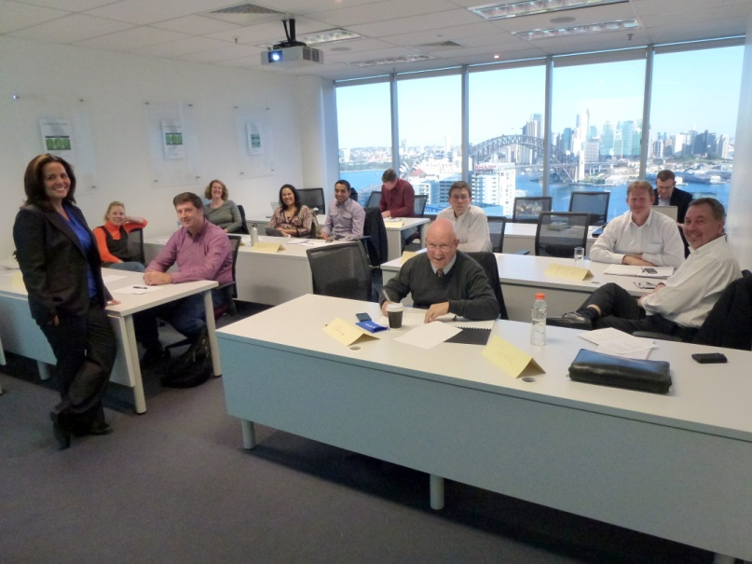
The Lessons Learned From Internal Project Surveillance
Class in the Paxus training room trying to focus on the
topic being presented rather than the amazing views of
the City, Harbour Bridge and Opera House from
the full length window at the rear of the classroom.

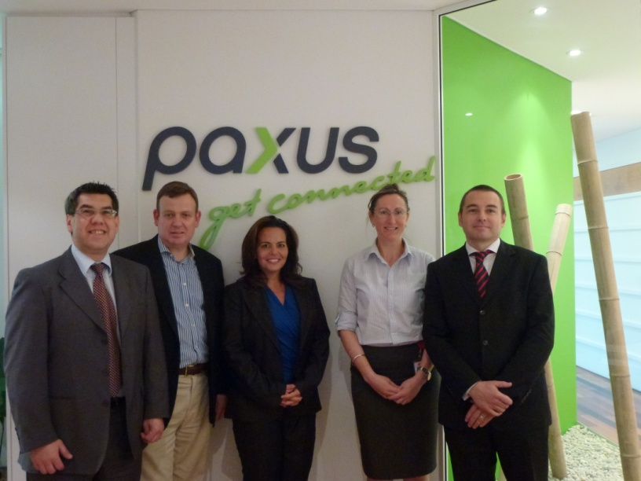

PMI Sydney Chapter Marketing Director, Gus Sabatino,
Kym Henderson, Ms. Lisa Wolf and Paxus Executives
Veronica Moran and Stephen Tompkins during a break at
the Lessons Learned from Internal Project Surveillance
class. Paxus now sponsor the PMI Sydney Chapter
Education events by providing the extraordinary venue
at their North Sydney Office.
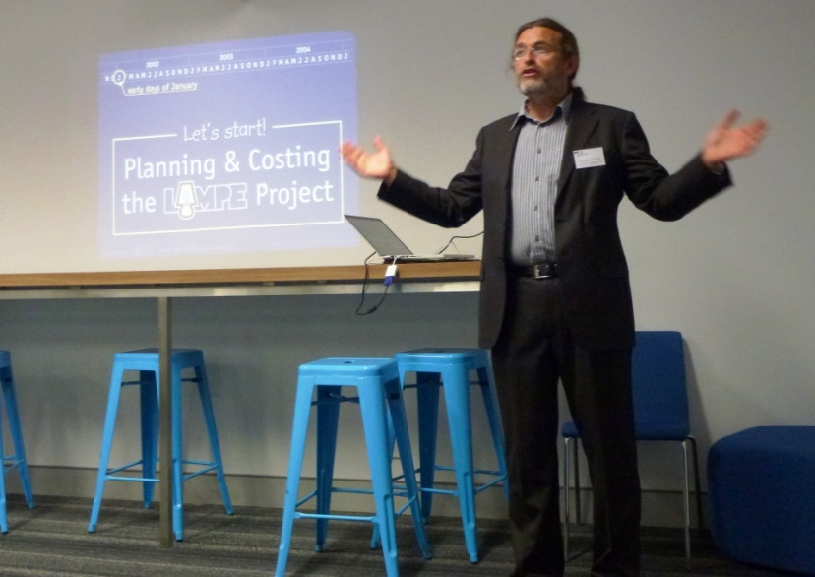

Professor Pierre Bonnal making a point during the final
presentation of his visit to the large PMI Canberra
Chapter audience. PMI Canberra was particularly
appreciative of being included in the initiative while
Pierre and Lisa Wolf appreciated the scenic road trip
down the south coast to Canberra and the opportunity
to visit the national capital along with Sydney and
Melbourne.

